MERGA Annual Conference Papers Template
Steven Smith  University of Utopia  s.smith@utopia.edu.au | Jane Jones  Utopia University  j.jones@utopia.edu.au
Third Author [Underline presenting author name(s)]
Institution
email [in all lower case]
Steven Smith, Jane Jones, & Third Author [This is for TOC and will not be visible in your paper, please add author detail]
Use this template to prepare your research/symposium paper. This document specifies the style and format of MERGA papers for the annual conference proceedings. The template contains MS Word ‘styles’ which authors must use to format their papers uniformly. Research papers (maximum eight pages in length) and symposium papers (maximum four pages each) include an abstract. Abstracts are no more than eight lines.
All papers at MERGA’s annual conferences must be prepared in Microsoft Word and submitted electronically. Papers accepted for publication following peer review will be published in the conference proceedings. Please adhere to the strict specifications on submitted papers for the final product to have a professional appearance. All relevant instructions for preparing your paper are contained within this Template document. Please use this document as a ‘template’ for your paper. The following guidance assumes that your paper is in-draft and needs to be formatted. All papers based on empirical research must contain a statement about the ethical conduct of the research prior to the reference list (see p. 5).
Introduction to Design and Format
The appearance of a document depends on design and format, where design refers to the overall conformance to a recognisable look-and-feel, like APA Style (https://apastyle.apa.org), while format refers to the specific instructions for how words and symbols are laid out on the printed page. Both are specified in this template, which has three purposes:
- To outline MERGA’s standard design specifications.
- To specify a uniform format for annual conference papers.
- To provide instructions on how to achieve this format with a minimum of effort.
MERGA Publications Style
MERGA conference papers should follow the standard MERGA publications design which follows APA Style as specified in the official guide to APA Style Publication Manual of the American Psychological Association (2020) and supplemented by recommendations for referencing electronic documents (available at https://apastyle.apa.org/apa-style-help), with minor modifications for MERGA (see below).
See Chapter 1 of the Publication Manual of the APA for valuable advice on the content and organisation of a manuscript and the expression of ideas. Most libraries will have a copy. Editorial style specified in Chapters 2 and 3 is followed and modified as specified below.
Modifications of APA Style for MERGA
The following modifications either amend APA style for Australasian usage or clarify and extend its application in MERGA publications.
Use Australasian academic English (not British or US English). The standard spelling reference is The Macquarie Dictionary (https://www.macquariedictionary.com.au). Spell words like ‘visualise’ with the ending -ise, not -ize, and words like ‘centre’ ending -re, not -er.
Place periods and commas outside closing quotation marks, unless the text quoted ends with a period. Insert a comma in lists of three or more items before the final ‘and’ or ‘or’ (e.g., “Bloggs, Bloggs, and Bloggs” and “1, 2, 3, or 4”). This provides consistency with the use of commas in references and may help to make the meaning clear.
Place a zero before the decimal point in all numbers less than one (e.g., p < 0.05) and use numerals when referring to class years such as ‘Year 8’ (otherwise write numbers smaller than 10 in words).
Formatting Specifications and Instructions
Typing or Pasting into the Template
Simply start writing your paper directly using this template and apply the styles as you go, or copy and paste your existing paper into this template using the following procedure:
- Open a copy of this template and delete all of the text except Appendix One.
- Open your manuscript file, select all and copy the entire text.
- Paste your manuscript text into this template before Appendix One. You can paste normally, or use ‘Edit’ menu, ‘Paste Special’, ‘Unformatted Text’. It is very quick to add the styles, and avoids battling with MS Word trying to retain old formatting.
Word ‘Styles’
A Word ‘style’ is a pre-configured set of parameters that define the font appearance and size, line spacing, indent/justification, keep-with-next, and similar, for each style. You effectively tell the word processor what style each paragraph in your document belongs to, and Word sets its appearance. Styles have many hidden benefits such as creating a table of contents.
All Word styles used for formatting MERGA papers have a name beginning with CONF and have been set up for all parts of a manuscript: various headings, author details, abstract, body text, quotations, table and figure captions, table cells, footnotes, references, etc. To return text to the default style select a paragraph and choose ‘Default Paragraph Font’ or to switch off all styling choose ‘Clear Formatting’ from the Style Pane.
It is essential that authors use the CONF styles provided to achieve uniformity of appearance of the final proceedings. Please refrain from editing styles in any way. If you do edit the styles they will revert to this template when pasted together into the proceedings. Have a good look at all the CONF style names; all the styles you are likely to need are included in the template.
Please check that the application of styles does not alter intended formatting preferences (e.g., remove existing formatting like italic, or change special symbols to normal text font).
Formatting Your Manuscript
Styles
Make formatting marks visible in your text (click paragraph mark symbol ¶ in the Home menu) then format each paragraph of your manuscript using the appropriate CONF style. The general procedure for applying a style is to select a paragraph and apply a style:
- First select the text to be formatted. Single click, or treble click to select all the text (including the paragraph mark ¶) or treble click/drag to select multiple paragraphs.
- Choose a CONF style from the Style Pane (Figure 1). The selected text will be automatically formatted. Do not adjust the style (e.g., do not reduce the font size in a table or vertical spacing around paragraphs).
- You may wish to ‘Clear Formatting’ (Styles Pane) before applying a new style.
To see the Styles Pane click on the downward arrow to the right of the Styles gallery in Windows (Figure 2; purple box) or the Styles Pane for the Macintosh (Figure 3; purple box).
Figure 1
Example CONF Styles in the ‘Styles Pane’ Showing CONFFigure Highlighted/Applied to the Figure
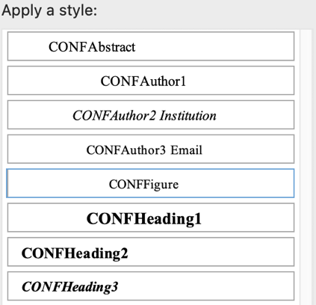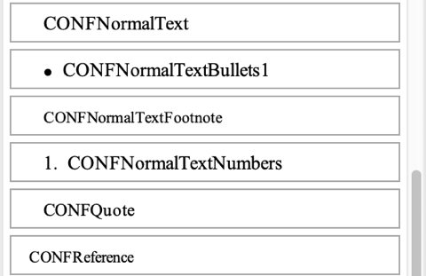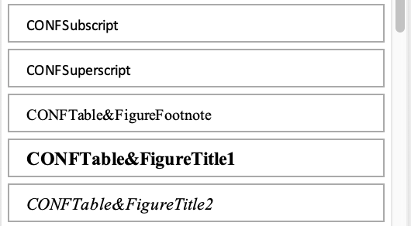
Figures 2 and 3
To Access MS Word Windows (1) or Macintosh (2) ‘Styles Pane’ Click in the Purple Box
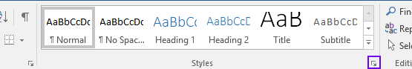
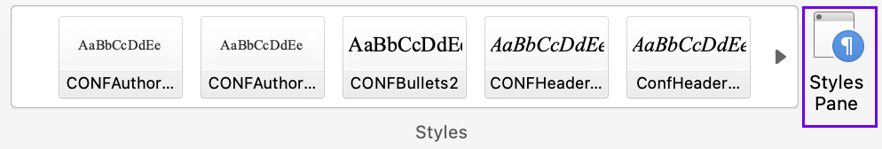
Titles
Apply CONFTitle to the title of your paper (or CONFTitleSymposium for Symposium title). Use a manual line break (SHIFT-ENTER) to specify the break if a title runs to two lines.
Authors
Apply CONFAuthor1 to each author’s first and last name (no title or initials). Please underline the presenting author name(s).
Apply CONFAuthor2 Institution to the name of the university or institution.
Apply CONFAuthor3 Email to the email address which is in all lower case.
For two authors, place each author’s details in a cell of a 1 × 2 table. Use a 2 × 2 table for three or more authors and merge the two cells in odd rows, if necessary.
Abstract
Every paper should begin with a one-paragraph abstract of not more than eight lines formatted in CONFAbstract. There is no heading before (or after).
Normal Body Text
All normal or body text paragraphs are formatted using CONFNormalText (https://apastyle.apa.org/style-grammar-guidelines/paper-format/paragraph-format). There is no need for different indentation after lists.
There are several sub-styles of CONFNormalText such as CONFBullet styles (see Lists below), CONFBlockQuote and CONFTranscript (for verbatim transcripts).
Spell out words like ‘and’, ‘for example’, and so on, except when they occur within parentheses (then use ‘&’, ‘e.g.,’, etc.). Always follow ‘e.g.,’ and ‘i.e.,’ with a comma.
Use italics for technical terms at their first definition (then plain), and for foreign words.
Headings
Apply CONFHeading1 to level 1 headings (such as Rationale, Method, Results, Discussion, Acknowledgments, and References). Capitalise all major words (verbs, nouns, adjectives, adverbs, and any words of more than four letters), including both parts of hyphenated words. There is no full stop at the end of headings. See https://apastyle.apa.org/style-grammar-guidelines/paper-format/headings for more information.
Apply CONFHeading2 to level 2 headings using title case, as above.
Apply CONFHeading3 to level 3 headings using title case, as above.
Quotations
For short quotations of fewer than 40 words “add quotation marks around the words and incorporate the quote into your own text” (APA Style Website, Short Quotations). See https://apastyle.apa.org/style-grammar-guidelines/citations/quotations. Normal text typically precedes a block (long) quotation and ends with a colon:
Format quotations of 40 words or more as block quotations [CONFBlockQuote applies the correct font and indentation]. Either (a) cite the source in parentheses after the quotation’s final punctuation or (b) cite the author and year in the narrative before the quotation and place only the page number in parentheses after the quotation’s final punctuation. Do not use quotation marks to enclose a block quotation. (APA Style Website, Block Quotations)
Text omitted within a quotation is shown by an ellipse consisting of a space, three dots (full stops) and another space. Do not use an ellipse at the start or end of a quote.
Lists
Lists may be bulleted (CONFNormalTextBullet1 or CONFNormalTextBullet2 for secondarily indented bullets) or numbered (CONFNormalTextNumber).
Bulleted lists (https://apastyle.apa.org/style-grammar-guidelines/lists/bulleted) are preferred to numbered lists for, for example, research questions which should be phrased as a bulleted list (even a list of one) before the method, and each line starts with an upper case letter and ends with a full stop.
Use numbered lists where the order is important starting with a capital letter ending with a full stop (https://apastyle.apa.org/style-grammar-guidelines/lists/numbered).
Numbers and Statistics
Numbers and statistics should be written following the APA Style guidelines (https://apastyle.apa.org/instructional-aids/numbers-statistics-guide.pdf) noting the exceptions listed below. Use non-breaking spaces (alt–0 windows or option-space mac) within equations.
You may wish to use the formula editor for mathematics formulas.
Tables and Figures
There is now consistency in setting tables and figures.
Place tables inline between paragraphs near to where they are cited. Copying and editing a table and titles from this template will give you an excellent starting point for the formatting.
A table title (caption) is set in two paragraphs: an identifier such as ‘Table 1’ in the first paragraph and text indicating the content of the table in the second paragraph (see an example on p. 7). All significant words are capitalised and there is no full stop at the end (https://apastyle.apa.org/style-grammar-guidelines/tables-figures/tables):
- Format the first title paragraph with CONFTable&FigureTitle1 and the second title paragraph with CONFTable&FigureTitle2. These are in Title Case with no full stop at the end. Each table must be referred to (cross-referenced) from the text.
- Format cells in the table header row with CONFTableHeading (default), CONFTableHeadingCentred or CONFTableHeadingRight. Table headings are sentence case with no full stop. and all other table cells using CONFTableText, CONFTableTextCentred or CONFTableTextRight, depending on the layout. Other styles such as CONFTableTextBullet1 are available.
- Tables are 100% the page width with ½pt horizontal rules (lines) spanning the full width of the table: above and below the table heading and below the last row. You may add shorter rules spanning fewer columns to indicate significant sections, if necessary. See APA/past papers.
- You should locate the table to be fully within a single page.
Place figures inline between paragraphs near to where they are cited. Copying and editing a figure and titles from this template will give you an excellent starting point for the formatting. Each figure should move with the text, be formatted CONFFigure, cross-referenced in the text and have captions similar tables using CONFTable&FigureTitle1 and CONFTable&FigureTitle2 above, as seen in Figures 1–3. Please export any images in high quality from Excel or other sources and embed them in your manuscript. Do not link figures.
Format table and figure footnotes using CONFTable&FiguresFootnote:
Note. A non-specific note in a paragraph ending with a full stop.
α Specific footnotes are identified by a superscript symbol, ending with a full stop.
* or ** Significance represented by one or two asterisks on one line e.g., *p < 0.05. **p < 0.001. The maximum number of asterisks should be equal to the number of different significance levels in that table.
Acknowledgments
Immediately prior to the reference list, include an acknowledgments heading (CONFHeading1) (if required) plus a single paragraph (CONFNormalText) that may include acknowledgement of the funding source and an ethics statement. The latter is required if empirical research is included. The ethics statement should use the following text, or similar:
Ethics approval [insert approval number] was granted by [inset name of university], and [insert participants and parents/caregivers as applicable] gave informed consent. See the MERGA Ethics Policy for more information.
References
Include a references heading (CONFHeading1). Format all entries in the reference list using CONFReference and individual reference elements following APA guidelines (see https://apastyle.apa.org/style-grammar-guidelines/references). We recommend using Endnote.
Use non-breaking spaces (alt–0 or option–space) to avoid separating e.g., authors’ initials from their surname and include DOIs as a URL (e.g., https://doi.org/10.1007/BF00138871).
Citing page number ranges in the reference list for chapters in a book (“This book (pp. 32–49)”) differs from articles in a journal (“This Journal, 58(2), 253–258”). Both use en–dashes (not hyphens, and no spaces) between numbers (while em—dashes are used between words).
For electronic documents, follow a similar format as for printed material and indicate when and from where it was retrieved.
Use ‘&’ instead of “and” in the reference list. Pay attention to the other specifications for listing references. Most variations are included among the examples given in the Publication Manual of the APA. The reference list in this template contains common examples.
The specifications for references to conference papers in the Publication Manual of the APA do not cover many of the conferences to which MERGA members frequently refer. See the examples provided in the reference list and the latest past proceedings.
Final Adjustments
There are a few final adjustments to check before the paper is submitted. For speed, use Find/Replace (Edit menu), to find e.g., two spaces and ‘Replace All’ with one space (repeat until none remain):
- Delete extra blank or unnecessary paragraphs (shown by a paragraph symbol ¶ when non-printing characters are displayed). Do not use extra paragraphs ¶ for formatting, for example, in a table or above or below figures.
- Change any two spaces e.g., between sentences, to one space.
- Delete any tabs (shown by an arrow → when you display non-printing characters ¶).
- Delete any page breaks (except between individual Symposium papers).
- Check that all quote marks (single and double) are ‘smart’ (as opposed to 'straight'). Either copy a left or right curly quote and paste it over a straight quote or delete the straight quote and type it again so that the auto-correct (Tools menu) corrects it.
- If you have used bold or underlined for emphasis, or in book or journal titles in the reference list, change these to italics (or use a character style called Emphasis).
- Apply CONFSubscript to all subscripts and CONFSuperscript to all sub- and super-scripts (including Table footnote letters) but follow APA on references.
- Edit the header to include the title of the manuscript and the authors names as indicated (please remember to overtype these, as well as identifying grant numbers and ethics approval numbers, with ‘*’ in any Blind submissions).
- Do not edit the footer.
- Check that all works cited in the text are listed in the references, and vice versa.
- Please proof-read all spelling in the text and references.
When you are sure that your paper is in its finished form and has been proof-read, save your file as a MSWord document (see Table 1 for naming conventions).
Naming and Submitting Conference Papers
Submission
Submission details including deadlines for manuscripts of papers will be posted on the conference website (see https://merga.net.au/Public/Annual-Conference/Submission.aspx).
Please submit a blind version of your research paper as well as the full, final version. Please also submit a fully completed Publication Agreement when requested.
To create a blind version that maintains the layout:
- Save your current file so that you know you have saved all the changes.
- Use Save As to save a copy of the manuscript with a different name (see Table 1).
- Replace every letter in every occurrence of each author’s name and institution (in the author list, text, headers and the references) with a star (*) in the blind version.
- Replace details of references in the bibliography that could identify the author(s) with a star (*) in the blind version.
- Replace details of ethics approval and grant numbers with a star (*) in the blind version.
It is your responsibility to ensure that the manuscript is anonymised as will not be edited centrally to remove any identifying material.
Table 1
Conventions for Naming
Presentation type and paper length | Blind version | Full paper
Research Papers [maximum eight pages in length] | Corresponding author last name_Blind_RP.docx  e.g., Smith_Blind_RP.docx | Corresponding author last name_Full_RP.docx  e.g., Smith_Full_RP.docx
Symposia Papers—submit as one document [maximum four pages in length per paper + one page overall introduction] | Symposium chair last name_Blind_SYMP.docx e.g., Jones_Blind_SYMP.docx | Symposium chair last name_Full_SYMP.docx e.g., Jones_Full_SYMP.docx
Short Communications [maximum one page in length] | N/A | Corresponding author last name_Full_SC.docx  e.g. Wang_Full_SC.docx
Round Tables [maximum one page in length] | N/A | Corresponding author last name_Full_RT.docx  e.g. Devi_Full_RT.docx
Posters | N/A | Corresponding author last name_Full_POST.docx  e.g. Ali_Full_POST.docx
Symposium Conference Papers
Symposium papers should be presented together in one document with a one page brief overview of the symposium, including a title, the names of presenters, an introduction to the theme/project, and a short introduction to each of the three–four contributions. Individual papers should be separated with page breaks. Please submit a full version and a blinded version.
Short Communications, Round Tables and Posters (Abstracts)
Abstracts consist of a single page submission based on this template with no separate abstract. Your submission will include a title, authors and possibly references. See examples from past conference proceedings. Please submit a full version and a Publication Agreement only (i.e. you do not need to submit a blinded version).
Submission Dates and Further Information
See Table 2 for a list of the submission dates and links to further information about each of the categories of submission from the MERGA website.
Table 2
List of Submission Dates for MERGA 46 (2024)
Early Bird Submission | 28 January 2024 | EB Information
Early Career Award Papers | 28 January 2024 | ECA Information
Research Symposia Papers | 28 January 2024 | RSP Information
Research Papers | 18 March 2024 | RP Information
Beth Southwell Practical Implications Award Papers | 18 March 2024 | BSPIA Information
Short Communications/Round Tables/Posters | 18 March 2024 | SC/RT/Poster Information
References
American Psychological Association. (2020). Publication manual of the American Psychological Association (7th ed.). APA.
Businskas, A. M. (2008). Conversations about connections: How secondary mathematics teachers conceptualize and contend with mathematical connections [Master’s thesis, Vancouver: Simon Fraser University]. CORE. https://core.ac.uk/download/pdf/56373465.pdf
Department of Education and Training, Victoria. (2016). STEM in the education state. Melbourne: DET. https://www.education.vic.gov.au/Documents/about/programs/learningdev/vicstem/STEM_EducationState_Plan.pdf
Gervasoni, A., & Peter-Koop, A. (2015). Comparing the development of Australian and German 7-year-old and 8-year-old’s counting and whole number learning. In M. Marshman, V. Geiger, & A. Bennison (Eds.), Mathematics education in the margins. Proceedings of the 38th annual conference of Mathematics Education Research Group of Australasia (pp. 261–268). Sunshine Coast: MERGA.
Graven, M., & Venkat, H. (2021). Piloting national diagnostic assessment for strategic calculation. Mathematics Education Research Journal, 33(1), 23–42. https://doi.org/10.1007/s13394-019-00291-0
Mitchelmore, M. C., & White, P. (1995, April 18–22). Development of the angle concept by abstraction from situated knowledge [Conference presentation]. Annual meeting of the American Educational Research Association, San Francisco, CA. https://files.eric.ed.gov/fulltext/ED416066.pdf
Outhred L., Farrell, J., & Cotter, K. (1996, July). How well do student teachers integrate science and mathematics concepts? A pilot study [Conference presentation]. Working Group 1 at the 8th International Congress on Mathematical Education, Seville, Spain.
Sowey, E. R. (2020). Statistics education that inspires long-term retention of learning: A qualitative model. Statistics Education Research Journal, 19(1), 21–28. https://doi.org/10.52041/serj.v19i1
Thornton, S., & Hogan, J. (2004). Orientations to numeracy: Teachers’ confidence and disposition to use mathematics across the curriculum. In M. J. Hoines, & A. B. Fuglestad (Eds.), Proceedings of the 28th conference of the International Group for the Psychology of Mathematics Education (Vol. 4, pp. 315–320). PME.
Truran, J., & Truran, K. (1998). Using clinical interviews in qualitative research. In J. A. Malone, B. Atweh, & J. R. Northfield (Eds.), Research and supervisions in mathematics and science education (pp. 41–63). Lawrence Erlbaum.
Vale, C. M. (2001). Gender and computer based mathematics in selected secondary classrooms [Unpublished doctoral dissertation]. Melbourne: La Trobe University.
Victorian Curriculum and Assessment Authority. (2015). Victorian certificate of education mathematics study design. Victorian Curriculum and Assessment Authority. https://www.vcaa.vic.edu.au/Documents/vce/mathematics/2016MathematicsSD.pdf
Appendix One. Styles Summary Sheet
Keep This Part of the Template in Your Manuscript Until you Have Finished Drafting
A list of all the styles is copied below. If you retain this Appendix until after you have finished editing then you can tell the word processor to display just the Styles in Use (Figures 4 and 5) when the Styles Pane is open on the right of your manuscript. If you use the Format Painter to copy a style ensure you copy the paragraph mark ¶ before applying the formatting to your own text (the paragraph mark holds the information about the paragraph style).
Note that text in grey is for information and may be deleted.
Figures 4 and 5
In The Styles Menu Under All Styles Choose ‘Styles in Use’ to Limit the Total List of Styles Displayed; The Format Painter (Paint Brush) is in Word’s Home Screen Below Copy and Paste
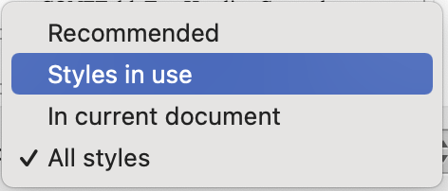
Title of Manuscript [CONFTitle; Title Case; no Full Stop]
Title of Manuscript Symposia [CONFTitleSymposia; as Above]
Author First Name and Last Name [CONFAuthor1]
Author Institution [CONFAuthor2 Institution (no Department); Title Case]
Author email [CONFAuthor3 Email; all lower case]
Abstract text [CONFAbstract; Sentence case with punctuation as appropriate].
Normal body text [CONFNormalText; Sentence case with uppercase proper nouns, etc. and punctuate as appropriate].
First Level Heading [CONFHeading1; Title Case; no Full Stop]
Second Level Heading [CONFHeading2; Title Case; no Full Stop]
Third Level Heading [CONFHeading3; Title Case; no Full Stop]
Normal body text [CONFNormalText; Sentence case with uppercase proper nouns, etc. and punctuate as appropriate.]
Table 1 [CONFTable&FigureTitle1; Title Case; no Full Stop]
Description of the Table or Figure [CONFTable&FigureTitle2; Title Case; no Full Stop]
CONFTableTextHeading | CONFTableTextHeadingCentred | CONFTableTextHeadingRight
CONFTableText | CONFTableTextCentred | - CONFTableTextBullet1
- CONFTableTextBullet1 | CONFTableTextRight | - CONFTableTextBullet2
Note. or symbol e.g., α [CONFTable&FigureFootnote; Sentence case; normal punctuation. See guidance on Footnote order and style above.]
- First level bullets [CONFNormalTextBullet1 start with capital end with full stop].
- Second level bullet always follows first [CONFNormalTextBullet2 as above].
- Numbered items where order is important [CONFNormalTextNumber as above].
Short quotations of fewer than 40 words “add quotation marks around the words and incorporate the quote into your own text” (APA Style Website, Short Quotations) are simply quoted with smart double quotes inline in CONFNormalText (no italics).
CONFNormalText typically precedes a longer block quotation and ends with a colon:
Format quotations of 40 words or more as block quotations [CONFQuote applies the correct font and indentation]. Either (a) cite the source in parentheses after the quotation’s final punctuation or (b) cite the author and year in the narrative before the quotation and place only the page number in parentheses after the quotation’s final punctuation. Do not use quotation marks to enclose a block quotation. (APA Style Website, Block Quotations)
Verbatim transcript of research or other data [CONFTranscript; Sentence case; punctuate as appropriate.]
Superscript characters should be in CONFSuperscript.
Subscript characters should be in CONFSubscript.
Hyperlinks are automatically applied when you enter a URL beginning http:// or https:// and press the space bar. The formatting is automatically Hyperlink or Followed Hyperlink.
The MERGA template also has some character styles (which differ from paragraph styles in that they only apply to the characters that they cover). For example, Italic can also be applied using a character style called Emphasis which is a more reliable way to apply italics.
The remaining styles in the template are all the built-in styles in Microsoft Word and can be hidden by choosing ‘Styles in Use’ (the default is Recommended, or All Styles) in the Style Pane (see Figures 4 and 5 above). Office Use Only
You do not need to worry about using the styles below because these provide the proceedings left and right page layout. When you add your author names and short title to the headers it will automatically be in the correct style.
CONFAuthorsForTOC
CONFAuthorsForTOCSymposia
CONFHeaderPaperTypeOdd
CONFHeaderPaperTypeEven
CONFHeaderPaperTitle
CONFHeaderAuthors

